Company Reader Experience

*Paul Mcgie*

*Joseph Mitchell*

*Andrew Tsai*

Contents

Design the Benefits into 3 Level Membership Systems: Survey Data Viewpoint (Q1 & Q4) 2

Design the Benefits into 3 Level Membership Systems: Secondary Data (Q1 & Q4) 6

Millennials 6

Gen X 7

Baby Boomers and up 8

Design the Benefits into 3 Level Membership Systems: Comparisons (Q1 & Q4) 8

High Donators 9

Benefits that Ranked High for All 9

Design the Benefits into 3 Level Membership Systems: Financial Model – Editorial Content (Q1 & Q4) 10

Model 11

Sensitivity – What If 12

Design the Benefits into 3 Level Membership Systems: Action Plan Summary (Q1 & Q4) 12

None 12

Bronze 12

Silver 13

Gold 13

Platinum 13

Elite 13

If your conjoint analysis provides you the following results, what do you learn from the results in terms of how much you charged for the benefit levels? Over-priced in any level? Not charging enough for any level? (Q2) 14

When we get some idea about the over-price vs. under-price cases, we can use our advertisement to help the over-price case, or highlight the under-price cases, etc. Any suggestions for these strategies? (Q3) 17

When we run the previous analysis, all respondents are treated as the same, but different “groups” or “segments” might value the benefits very differently. Based on your previous analysis (Group activity 1, related analysis on segmentation, etc.) how do you adjust for your conjoint analysis (just proposal is enough) (Q4) 18

# Design the Benefits into 3 Level Membership Systems: Survey Data Viewpoint (Q1 & Q4)

Our packages are going to reflect what will bring us optimal donations. With that said, we need to segment markets and corresponding services that will reflect the highest potential to increase donations. Some of the data below will be re-iterated from part one, but emphasizes the importance of our membership tiers.

On just the basis of age and those who do donate, we see ages 60-64 as receiving the highest “score”. This “score” indicates that overall, combining the average donation level and the population, we come to our best age group of donators. Given the current offerings of Company and no added benefits, we could assume that people within this age group are more likely to remain a donator regardless of any additional benefits. With that said, they are the ones with the highest volume of donators and give a high donation level; therefore it is important to appeal to this group.

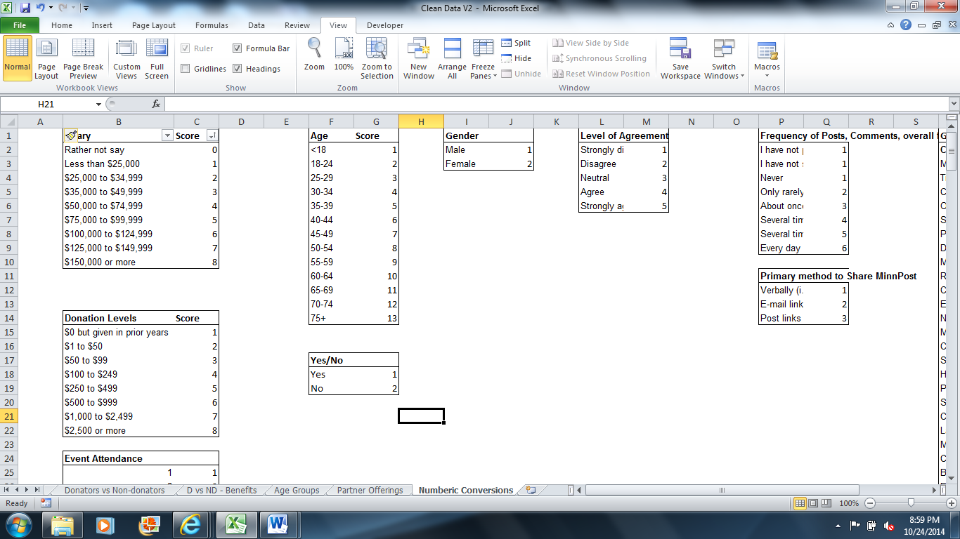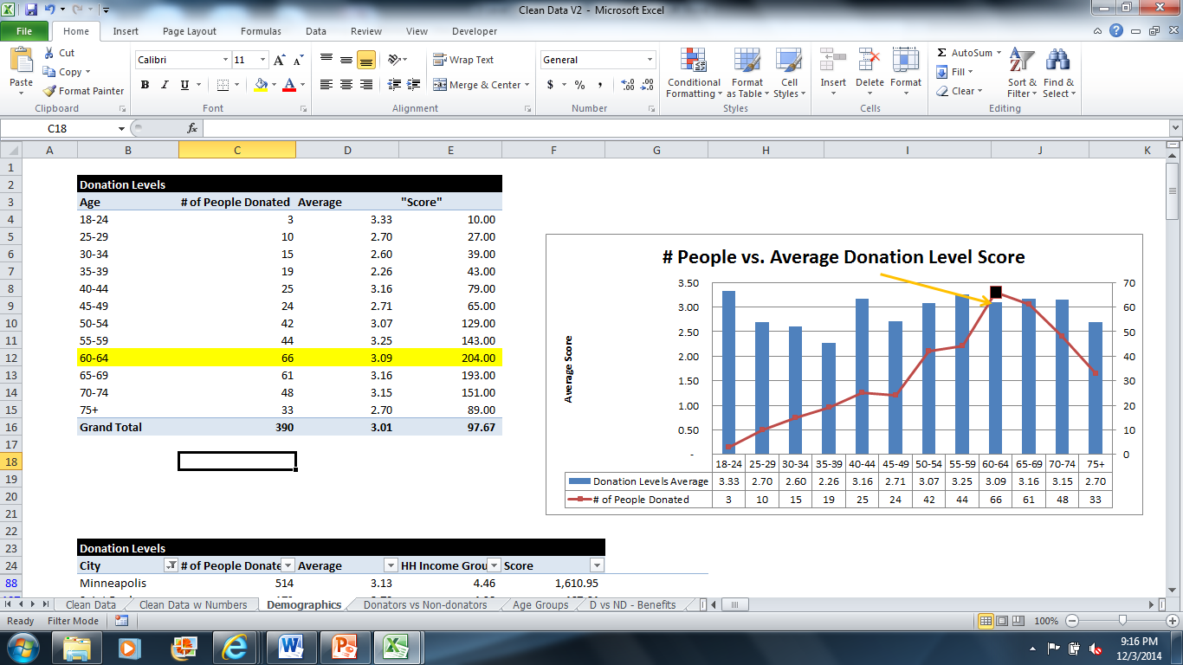

In general, we see that within the age groups of 50-74, we get much higher scores; we see higher volumes of donators as well as higher donation levels. This is only part of the equation though, looking at our weighted average score of household income per age group, we can see more potential on the horizon and an ideology to have different price tiers to attract different ages with different benefits. For instance, we see a big leap in household income from 25-29 to 30-34. While our current donation scores indicate lower “scores” for younger demographics, this should not be reflected as a lost cause, but an opportunity to grab that segment and engage and retain at a younger age, so that when that age group goes from 25-29 to 30-34, they will have more skin in the game and more initiative to support Company.

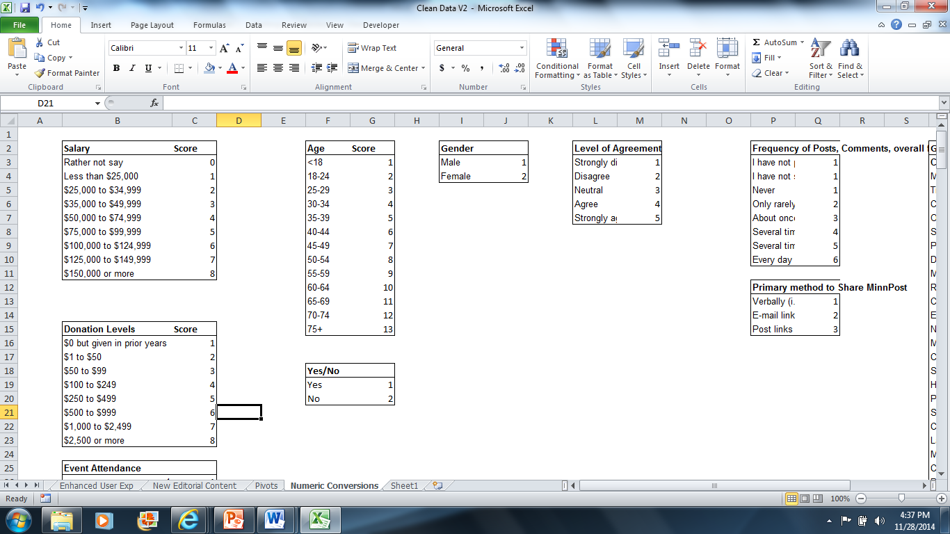

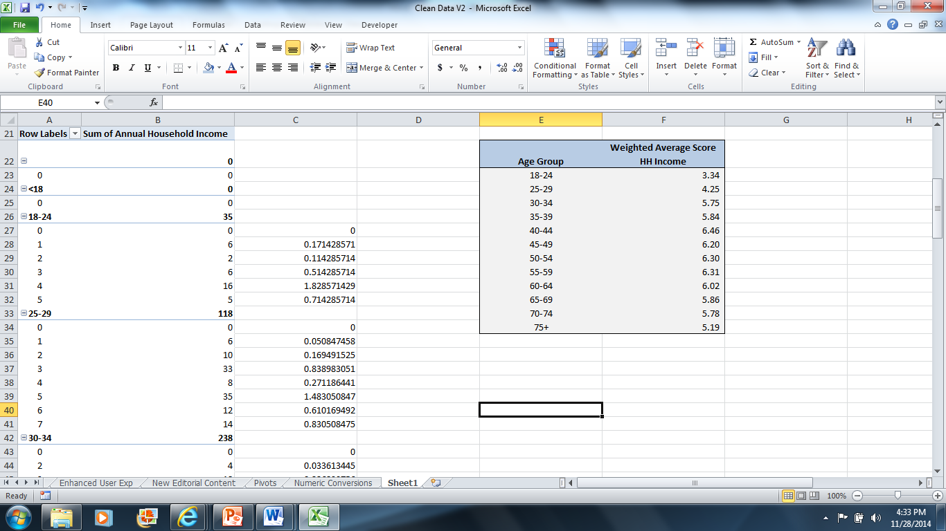

Furthermore, we need to look at what factors drive or could drive donations. Within our data we can view this in a couple ways: (1) by using our survey scores from 1 to 10 and creating our weighted averages and analyzing per age group and/or (2) dissecting our data and corresponding age groups by the “top 3” benefits selected.

First, let’s take a look at the data the first way. From the table below, we have highlighted per age group the top 3 means of scores for each age group per benefit. From this data, we can see that there is a much higher emphasis at a younger age on partner offerings and Company events and experiences. This shifts at the age group of 45-49, with partner offerings still being very important, but less of an emphasis on events and experiences. Overall, across all age groups, partner offerings takes the cake, while new editorial content and an enhanced user experience comes at a close second and third. From those three, nothing else scores above average given our distribution of weighted averages.



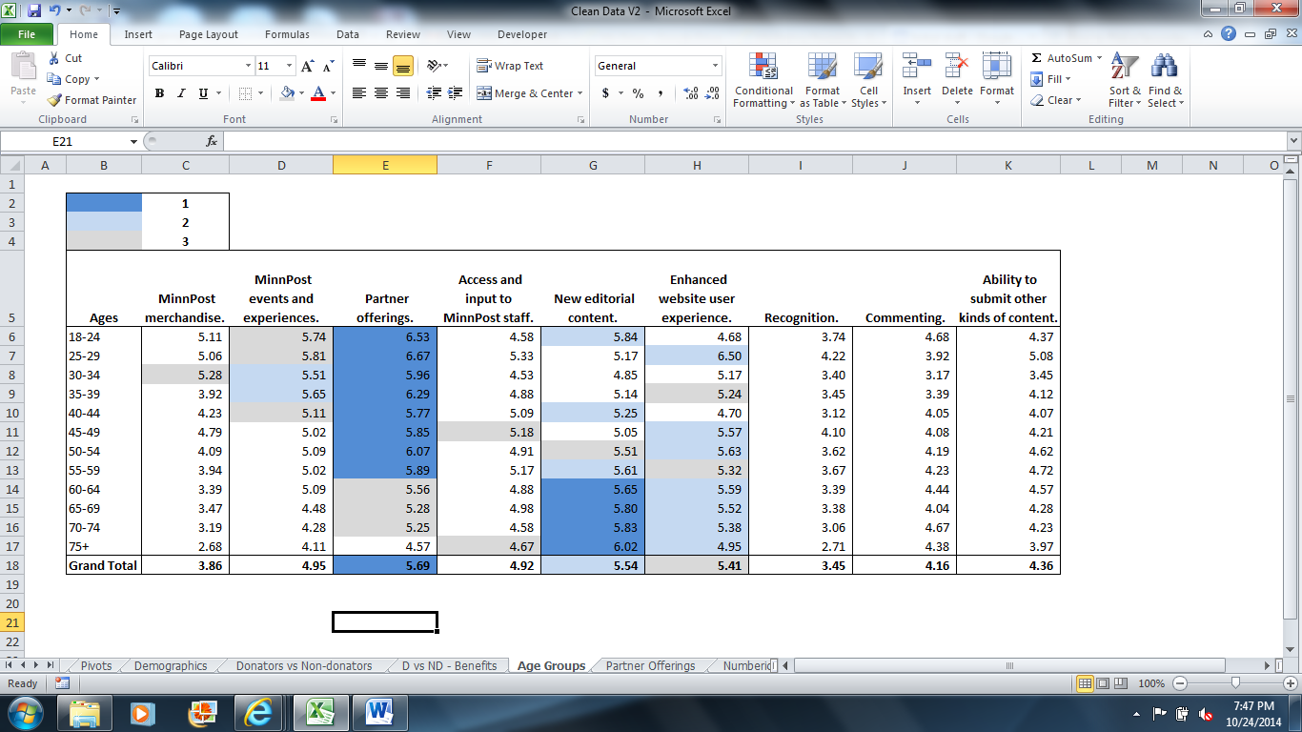

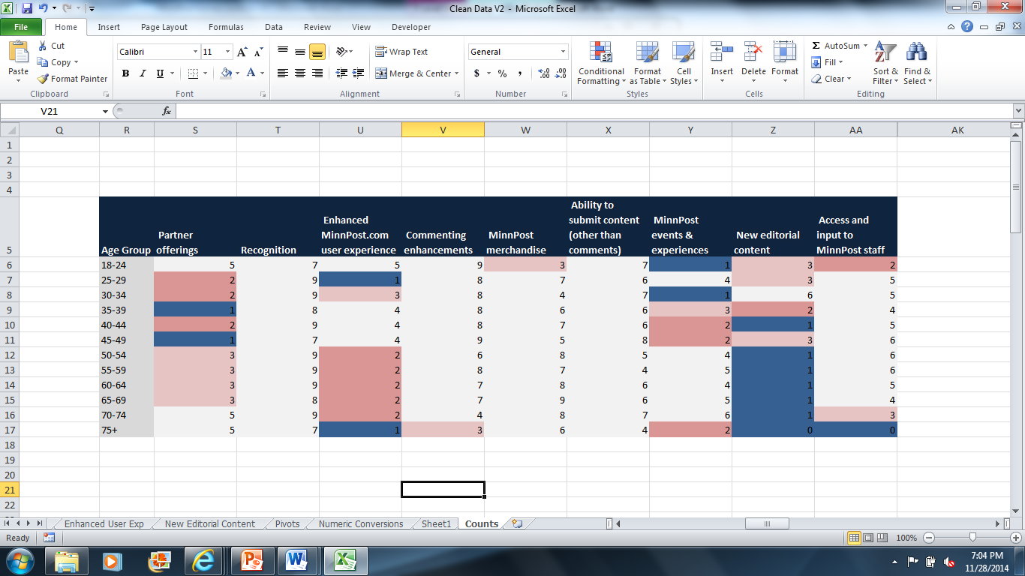If we look at it assigning scores to top three picks, there are slight differences though. For these scores we assigned weighted scores based on a ranking of 1 getting a score of 3, ranking of 2 getting a score of 2, and ranking of 3 getting a score of 1. We then timed it by the percentage per sample age group to get our weighted average scores.



Why does this matter? It makes our data less skewed and less bias as it eliminates extreme scores by attributing a top three rather than assigning scores from 1 to 10. With that stated, we still see common trends as events and experiences are more important to a younger demographic than an older demographic and editorial content remains important across most age groups. What changes is a different perception of the degree of importance. Partner offerings are not as important as previously noted given the top 3 ranking system as new editorial content becomes now the top benefit.

Finally, we want to look at income. We dissected per income groups and what they find important.

Using weighted averages, we can determine what is most important to each income tier. For example, people who make $150K or more have a high emphasis on partner offerings, a component which seems to not be offered at Company, or at least is not very visible to the person that visits their site. In each table, you will notice the conditional formatting highlighting anything that is above neutral. The tables also indicate the highest ranking score in each group, non-donator, $1 to $50, $50 to $99, etc. From these charts, we can see patterns and general consensus on which items are most important.

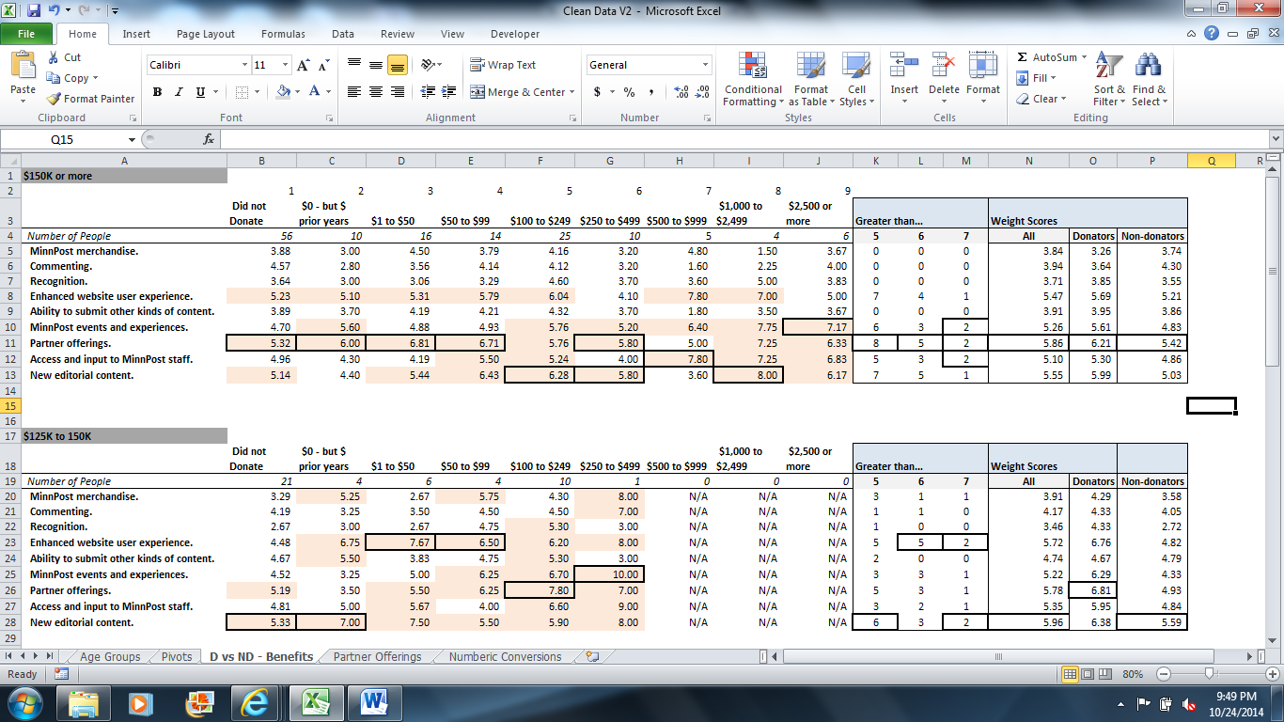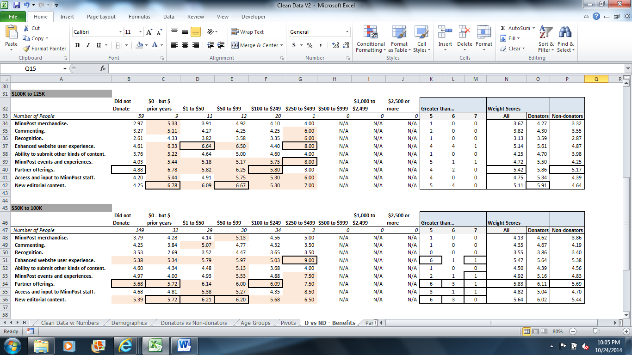

In the end, we can use our weighted averages and get an ultimate weighted average. What is interesting is how very uniform interests are. The rankings between donators and non-donators are very similar.

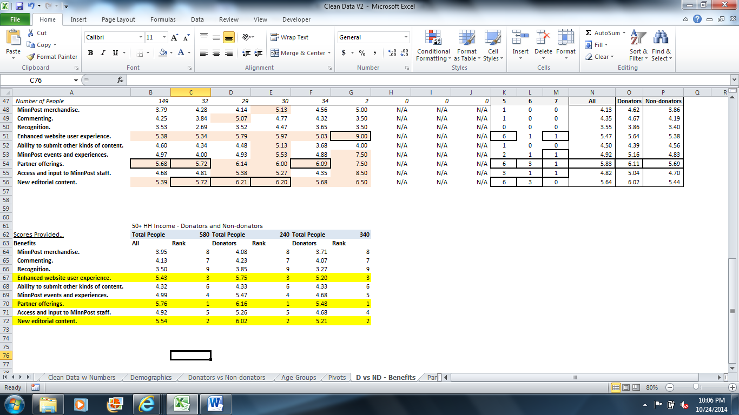

# Design the Benefits into 3 Level Membership Systems: Secondary Data (Q1 & Q4)

## Millennials

Considered the ages of 19-34, it is important to segment out this population and market differently to them. Not only does primary data support it, but secondary data supports this as well.

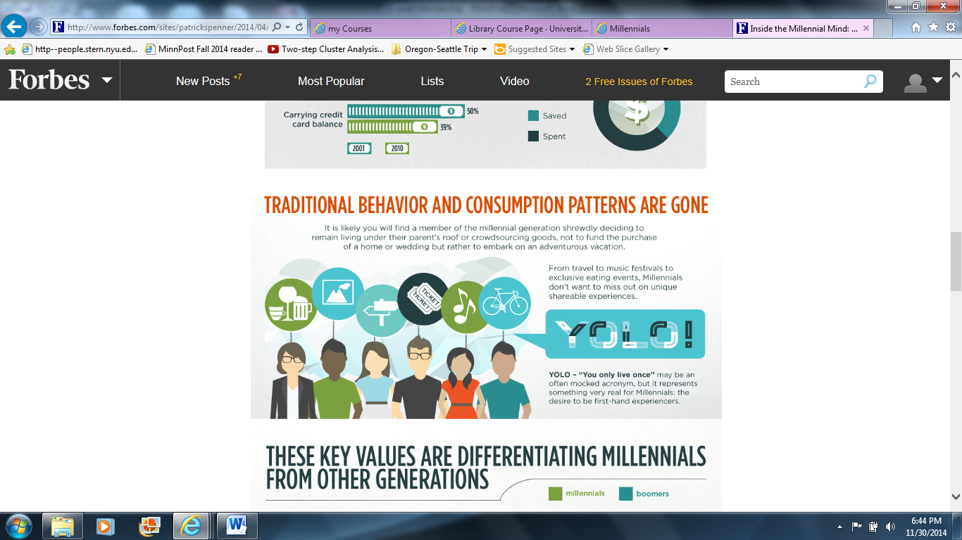

*www.forbes.com/sites/patrickspenner/2014/04/16/inside-the-millennial-mind-the-dos-donts-of-marketing-to-this-powerful-generation-3/2/*

Not only are millennials the current largest population in the U.S., but they are due to a huge change in lifestyle. In the next five years Millennials purchasing power will increase and their roles will change as we see more millennials become parents and more millennials making bigger moves in the workforce. By 2015, they’ll make up half of the workforce and by 2020 they’ll make up 75% meaning an increase in purchase power.

In general, Millennials are focused on amassing life experiences rather than tangible objects. As noted above, the tagline YOLO (You Only Live Once) along with our primary data reflects that and drives the notion of promoting unique events and experiences to this age group.

Minneapolis is one of the fastest growing cities in the US for Millennials. Some reasons include its lower unemployment rates, higher college graduation rates, and less income inequality. In fact, Millennials are the largest generational demographic in Minnesota. In 2012, they accounted for 28% of the population.

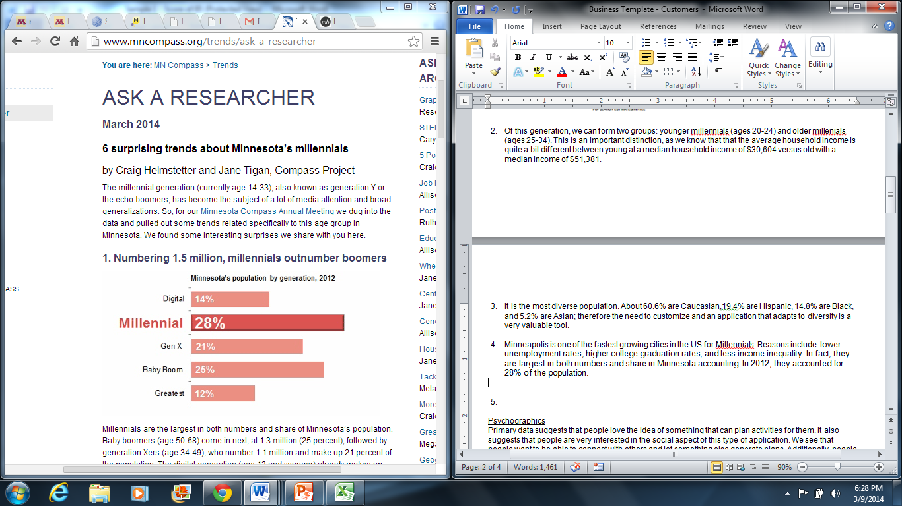

*http://www.mncompass.org/trends/insights/2014-03-01-minnesota-millennial-trends*

## Gen X

Considered the age group from approximately 35 to 50, Gen X make around 16-18% of the U.S. population (depending on how you slice the age group). In Minnesota, they make around 21% of the population. The most important thing to note, is that Gen X is entering or has entered into their peak earnings and spending years. This is also backed up by the survey. The weighted average income scores as shown having the highest income is from the age group of 40 to 45 years old.

Gen X has a strong memory and desire to return to pre-recession life, and want to recapture their wealth. Gen X faces many economic challenges to fulfill this desire. The focus is to provide a product that is seen as a necessity. With that said, according to Nielson in a 2010 study (American Generations: Who They Are and How They Live), they spend 27% more on entertainment than the average consumer. This supports the survey results of setting a higher importance for events and experiences as well as having a high importance on partner offerings. They might not be as extreme as the tagline YOLO, but they do want to live a balanced life, and offering the option of partaking in events is appealing to this age group.

## Baby Boomers and up

In our data we see that the top three donating groups fall within 60-74 year olds. They also compose 37% of the Minnesota population. Baby boomers are considered to have the highest purchasing power. This means that for the time being, it is most likely that 50+ should be able to contribute the highest dollar amount as well as highest volume of donators.

In a study by Hartford Financial Services Group for the 50+ age group, it found the following:

* 67% of people over 50 donate to causes they support. Of those surveyed age 49 and younger, approximately 60% donate money to charities.

In the end, 50+ care more about value than brand name. This makes sense as the older generation places higher emphasis for editorial content.

# Design the Benefits into 3 Level Membership Systems: Comparisons (Q1 & Q4)

Events and experiences for Gen X and Millennials show significance when compared to the 50+ age group.

Now, notice the higher scores when diving into the subsections for partner offerings. The mention of state parks, artistic performances, discounts to restaurants seems to back up the theory of the need for Millennials to experience life to its fullest.

## High Donators

High Donators, while much of their preferences were in line with much of the other population. The one thing that did stand out was access and input to staff.

## Benefits that Ranked High for All

Two things that seemed pretty consistent were the need for new editorial content and an enhanced user experience.

For editorial content, users just want more content and longer, more in-depth articles.

For Enhanced User Experience the top three were as follows:

1. Improved site search bar, with ability to sort and filter search results by relevance, author, section, publish date, etc.
2. Save-to-read-later functionality (like a Netflix queue for Company stories)
3. "You might have missed..." list that recommends recently published stories that you haven't read on topics of interest to you.

In the end, we see a trend that continues to become more and more apparent. People of all ages want customization. Mass customization is becoming more and more prevalent and will be even more so in the future.

# Design the Benefits into 3 Level Membership Systems: Financial Model – Editorial Content (Q1 & Q4)

In order to further our analysis, we wanted to run a simple financial model on the gains of new editorial content. Everyone wants more editorial content and this is something we can provide both more in the long-term as well as the short-term. The question becomes though, how much do we supply per the donation levels?

Assumptions (Provided by Andy Wallmeyer)

1. The average article online is on average 650 words.
2. The average cost of an article is $200.
3. On top of these costs are editorial salaries of $55,000 per year. It currently takes a team of 3 to handle the volume that is currently on site.
4. There were 41 articles from December 1 to December 3, meaning if we are going to take that number and divide by three and subtract by one to get a slightly more conservative number of 12 articles per day which means 4,380 articles per year.

## Model

While the model below isn’t anything too complex, it does provide an idea of the cost of content and the new members needed if new editorial content were to be the only benefit added. The model below shows the break-even of members provided the annual memberships of $60, $200, and $500.

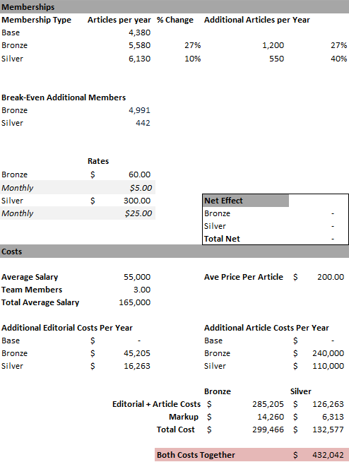

## Sensitivity – What If

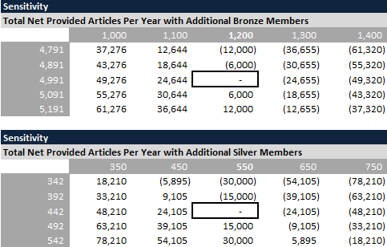The sensitivity tables to the right indicate the impact of the change in articles as well as our membership additions. Membership additions are located on the vertical axis and article additions are located on the horizontal axis. As you can see by our sensitivity and even by our break-even, our intention is to draw a larger crowd overall. We are aiming for much higher volumes of $60 annual memberships. Provided that new editorial content is something equally desired across age groups, income and donation levels, we thought it would be best to create volumes of memberships. We feel strategically this is also the best way to maximize our gains. We feel that we can still provide even slightly more content to higher donators, but it would not be as beneficial. For the $500+ donators, we see that access and input to staff is much more important to high donators than any other group.

# Design the Benefits into 3 Level Membership Systems: Action Plan Summary (Q1 & Q4)

While we would like to do further financial analysis, we feel that the membership groups below reflect the interests that the different demographics and groups can afford that will also maximize revenues for Company. While the assignment stated a 3 level membership system, we feel that there are too many variables to limit it to 3 membership levels. Instead, we expanded it to 5 levels.

## None

We determined that the goal of this was to increase active users or current donators to donate or donate more, so to expand on content while not charging for it, is not in line with the goal of Company. Company already grabs 350K unique users a month, so it needs to grab the interest of those users and rope them in to donate by offering membership tiers with benefits. With that said though, there should be semi-annual “special” events or even possibly monthly happy hours to engage the Millennial generation.

## Bronze

Our lowest “scores” on donator age groups are 18-34. We need to raise engagement and donation levels within that group, so by offering a price of $5 per month we capture that market. We also know from our secondary data, that Millennials are a significant chunk of the population, and by their increase in purchasing power, they will have a major impact on the market. To ignore that potential is not smart, so to offer benefits at a lower price and get them involved at that age should lead to much better donations when they reach their peak income around the age of 40-44. We also know with this group that they thrive on unique shareable experiences, so to offer partnership offerings and events and experiences within this tier is very important. In general, partner offerings seem to be one area that all groups seem to enjoy though, so Company needs to bolster their offerings to all demographics as they currently do not offer any.

Overall, we want more people to get “skin” in the game, and one of the short-term solutions is to add content. We wanted the biggest spike in content to our lowest membership. From our base to our current content, we increase our content by 22%. In addition, people want customization. So, with this new content, Company should invest in an algorithm that would recommend reads to the user as well as the save later functionality.

## Silver

Silver offers much of the same as bronze. It recognizes the fact the Gen X is currently in a stage of life where their purchasing power has increased substantially from their younger years. They too show high emphasis on partner offerings and events and experiences. With that said, they are donating more in the year, so we would offer the same level of discounts, but more opportunities for pre and post show events as well as other events and experiences. Overall, they would be higher in the pecking order and have more opportunities.

## Gold

Going with more content means a happier consumer, we increase the level of content, but at a declining rate. We wanted to capture the bulk of the population, but we still offer some additional content. With that, we provide the opportunity for this group to suggest stories and/or questions they would like to see MP reporters ask newsmakers; hence, some of that new and additional content will be reflective of their suggested stories.

## Platinum

We see even more content at this level, but as stated before at a declining rate. Company should have website recognition for anyone that donates $500 or more a year. We do this because even though it has a much lower ranking, it’s cheap. Also, as a small token, we want to give added benefits such as a couple free tickets to a performance and/or free MinnRoast Tickets.

## Elite

At the highest level, we want to give something that is priceless, members-only opportunities to preview and give Company feedback and behind the scenes coverage. At the highest levels of donating, we saw that access and input to staff ranked high. Also, not only do we want to give free tickets, but we want to give free premium tickets to this group in recognition of their high donations.

Here is a summary (if stated in prior level it then carries over into the next level).

|  |  |  |
| --- | --- | --- |
| Membership Level | Price | Benefits (Added Benefits for each Tier) |
| None | $0 | Current Content on Website, semi-annual special events |
| Bronze | $60  ($5/mo.) | 1. An overall increase of 27% in content (1,200 articles per year) 2. Discounts to performances, restaurants (foodies), retailers, events, etc. 3. Ability to purchase MinnRoast tickets before available to none members 4. Awareness and ability to get tickets/access before none members for speakers (like TED Talks), happy hours, etc. 5. Netflix-like customization 6. Email Recognition |
| Silver | $120  ($10/mo.) | 1. Higher in pecking order for pre-ticket sales (this continues with higher membership) 2. More Opportunities and discounts for unique events 3. Members-only pre and post show |
| Gold | $300  ($25/mo.) | 1. An overall increase of 10% in content from Bronze (550 articles per year) 2. Ability to suggest stories and/or questions you would like to see MP reporters ask newsmakers 3. Discounted Tickets to MinnRoast |
| Platinum | $500  ($41.67/mo.) | 1. A couple free tickets to MinnRoast 2. Memberships to other organizations 3. Website Recognition |
| Elite | $1,200+  ($120/mo.) | 1. Behind the scenes events at Company (tour of the company, shadow a reporter, etc.) 2. Members-only opportunities to preview and give Company staff direct feedback on MP Coverage 3. Premium Tickets 4. A couple free tickets to performances 5. Highest Website Recognition |

# If your conjoint analysis provides you the following results, what do you learn from the results in terms of how much you charged for the benefit levels? Over-priced in any level? Not charging enough for any level? (Q2)

|  |  |  |
| --- | --- | --- |
| **Rating** | **Coef.** | **Sig** |
| **Price 20** | **Base** | **0.01** |
| **Price 40** | **-1.9** | **0.01** |
| **Price 60** | **-3.4** | **0.01** |
| **Price 120** | **-4.5** | **0.01** |
| **Benefit 1** | **Base** | **0.01** |
| **Benefit 2** | **2.4** | **0.01** |
| **Benefit 3** | **3.5** | **0.01** |

If in fact, we were to test our assumptions and received the provided results above, we could interpret as follows. From our base of $20 to $40, our rating drops 1.9 units. From $20 to $60 our rating drops 3.4 units. Finally, from $20 to $120 our rating drops 4.5 units. Hypothetically in this case, our significance number is .01, meaning we have high confidence in these coefficients.

For the graphs below, we plot a hypothetical number of memberships on the Y-axis and price on our X-axis. Plotting each one separately we can see the degree of change. Plotting them all on one trend line, we see that as the price increases, the drop in ratings accelerates. Translating that into memberships, as the price increases, we would likely see a larger amount of people foregoing memberships.

The best price depends on where our Y-intercept lies or where our membership lies at our base offerings/price. For example if we have at our base 500 members and only want to change our price and not any benefits, we could maximize revenue at a price point of $74, meaning that $60 is considered underpriced and $120 is considered overpriced. This of course assumes that ratings are directly translated into an equivalent rate of loss memberships.

Now if we look at the benefits, our interpretation can be as follows. If we go from our base of benefit 1 and add benefit 2, our rating increases by 2.4 units. If we go from our base and then add benefit three, our rating increases by 3.5 units. Knowing this and our significance, we can easily state that benefit 3 has a much higher impact than benefit 2. Just knowing the data from our table, we could then counter-balance the effects of the negative ratings from our increased prices with our added benefits. Provided this information, we would want at least two different tiers, one at $40 with benefit 2 and one at $60 with benefit 3. Providing a third tier with even more benefits is a possibility to hit a more premium group, but the data does not provide enough detail to support that theory.

In the end, maximizing our returns is impacted by how ratings translate into memberships. The ultimate goal is to take the most money to the bank, not always necessarily the most members.

Each new tier will have a marginal cost associated with them. However, most of the benefits will have a low variable cost, because the benefits can be accomplished through partnerships with local organization. These of course will require staff or volunteer time, but little else.

|  |  |  |
| --- | --- | --- |
| Membership Level | Price | Costs |
| None | $0 | No further costs to Company |
| Bronze | $60  ($5/mo.) | 1. Increase in content: ~5000 new Bronze members and ~440 Gold for breakeven. 2. Discounts: 1/8 FTE 3. Ability to purchase MinnRoast tickets: no cost 4. Awareness and ability to get tickets: 1/16 FTE 5. Netflix-like customization: 1/8 FTE 6. Email Recognition: 1/16 FTE |
| Silver | $120  ($10/mo.) | 1. Higher in pecking order for pre-ticket sales: no cost 2. More Opportunities and discounts: 1/8 FTE 3. Members-only pre and post show: 1/8 FTE |
| Gold | $300  ($25/mo.) | 1. An overall increase of 10% in content: ~5000 new Bronze members and ~440 Gold for breakeven. 2. Ability to suggest stories: 1/8 FTE 3. Discounted Tickets to MinnRoast: no cost |
| Platinum | $500  ($41.67/mo.) | 1. Memberships to other organizations: 1/8 FTE 2. Website Recognition: 1/16 FTE |
| Elite | $1,200+  ($120/mo.) | 1. Behind the scenes events: 1/16 FTE 2. Members-only opportunities: 1/8 FTE 3. A couple free tickets to performances: 1/8 FTE 4. Highest Website Recognition: no cost |

This in total will require 1 1/4 FTEs to implement, alongside the content additions which will require 4991 new Bronze tiered members, and 442 Silver tiered members. These numbers are very high, but will drop precipitously as higher tiered members (Silver, Platinum, and Elite) join.

# When we get some idea about the over-price vs. under-price cases, we can use our advertisement to help the over-price case, or highlight the under-price cases, etc. Any suggestions for these strategies? (Q3)

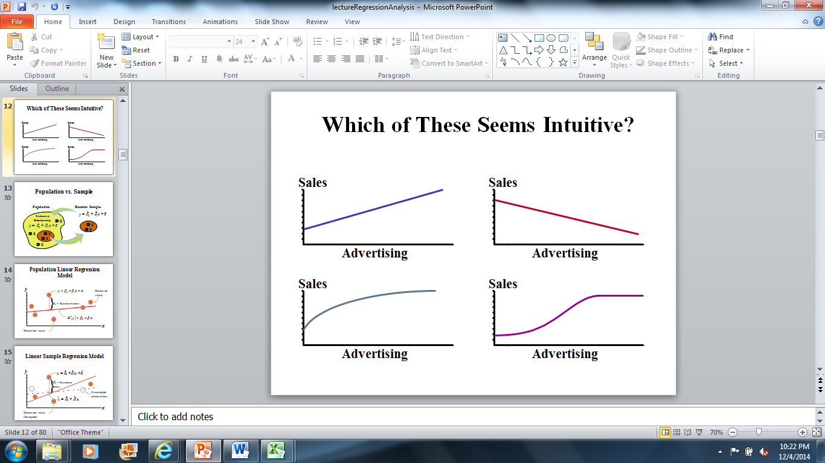

We would need to run further analysis, but provided there are 350K unique users a month and is somewhat well known in the Minnesota region, we would probably see a graph that would initially accelerate in sales due to advertising, but would then plateau as we hit our peak population or market within Minnesota. Also, while we have unique visitors, it doesn’t always translate into memberships.

Based on primary event sites in Minnesota, such as traffic to Vita.mn (and people who buy things on it), our research indicates that Company might max out at 135,000 memberships in Minnesota (depending on where they go with pricing memberships). Once the original market reaches maturity (approximately 135,000 users), they will need to start to move into a new market to spur continued membership growth. The idea is that when membership in a region hits an inflection point, we go on to the next phase of membership growth by expanding into new regions. Regions for growth will be chosen based on their demographic similarity to the Minneapolis market. This will be determined by mining data from our current user base, as well as our team’s ability to develop connections in those markets. Initial targets for Phase I expansion might include Milwaukee, Denver, Seattle, Portland (OR), San Francisco and Austin (TX). Initial targets for Phase II expansion would be Chicago, Boston, Houston, Dallas, Atlanta and Phoenix. Expansion into New York and Los Angeles would require significant resources and expertise that Company would unlikely possess from the start. So Company should focus on smaller markets to begin with, with the goal to expand into these cities once they have proven the concept and value proposition of the membership levels. Revenue would follow the same pattern as total users.

According to SBA.gov, advertising costs is about a 1/3 of starting a business within the first year, and then after that marketing remains at about 7-8% of revenues. With that said, we know the normal range of advertising. So, advertising to boost over or under priced membership levels is not the key. The perfect combination of advertising, benefit and price is the key.

# When we run the previous analysis, all respondents are treated as the same, but different “groups” or “segments” might value the benefits very differently. Based on your previous analysis (Group activity 1, related analysis on segmentation, etc.) how do you adjust for your conjoint analysis (just proposal is enough) (Q4)

See prior analysis, but the idea is to separate and dissect in the following segments:

1. High Donators
2. Age Groups
3. Income

From these groups and from our analysis above we see that we can test benefits for the above groups as our research suggests varying level of interests for different groups.

